- In web browser type the IP Phone IP address
- Username: admin
Password: 1234

- Click Configuration > Voice Over IP > Signaling Protocls
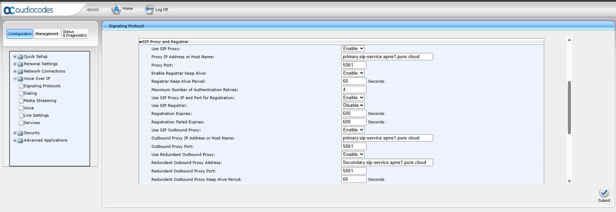
- Change Use SIP Outbound Proxy to Disable
Change Redundant Outbound Proxy to Simultaneous
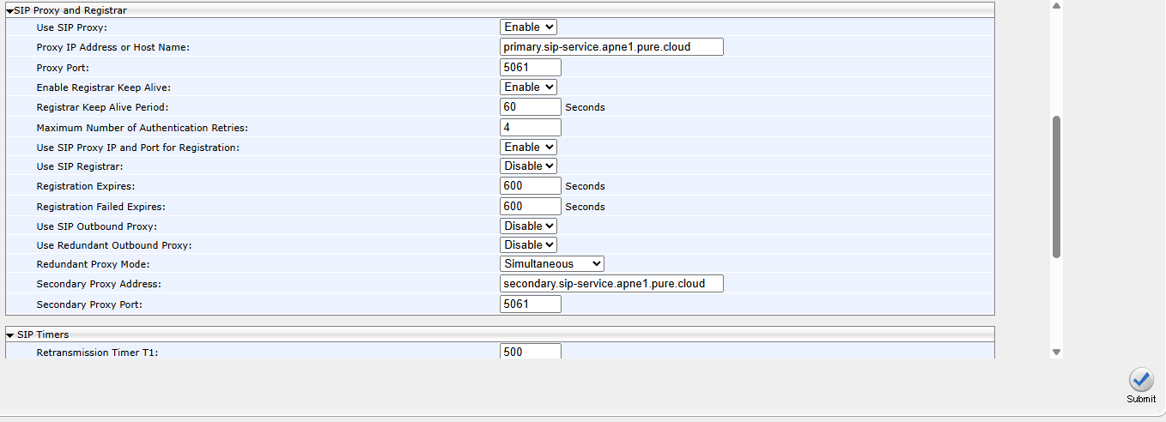
- Click submit

